Ideation Phase
Empathize & Discover

Date | 31 January 2025
Team Id | LTVIP2026TMIDS36439
Project Name | Toycraft Tales Tableau's vision into Toy manufactures Data
Maximum Marks | 4 Marks

Empathy Map Canvas
Definition :
- An Empathy Map is a collaborative visual tool used to articulate what a team knows about a particular type of user.
- It externalizes user knowledge in order to create a shared understanding of user needs and aid in decision-making.
- The map is divided into sections that capture what the user Thinks & Feels, Sees, Says & Does, and Hears, along with their Pains and Gains.
Purpose:
- Understand the User: To help teams better understand their users by seeing things from the user's perspective.
- Identify True Problems: To identify the real challenges and goals a user experiences, which is essential for creating an effective solution.
- Team Alignment: To help participants consider the user's goals and challenges together, ensuring the whole team is focused on the same user needs.

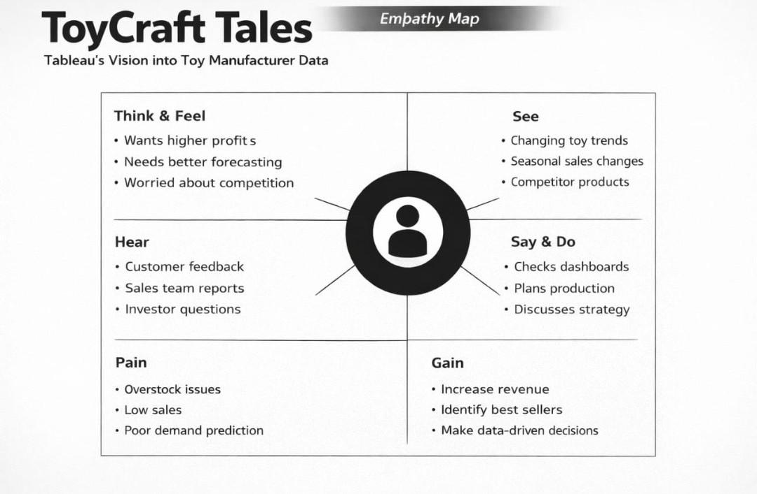

Reference: https://www.mural.co/templates/empathy-map-canvas

Example :

